Lab3

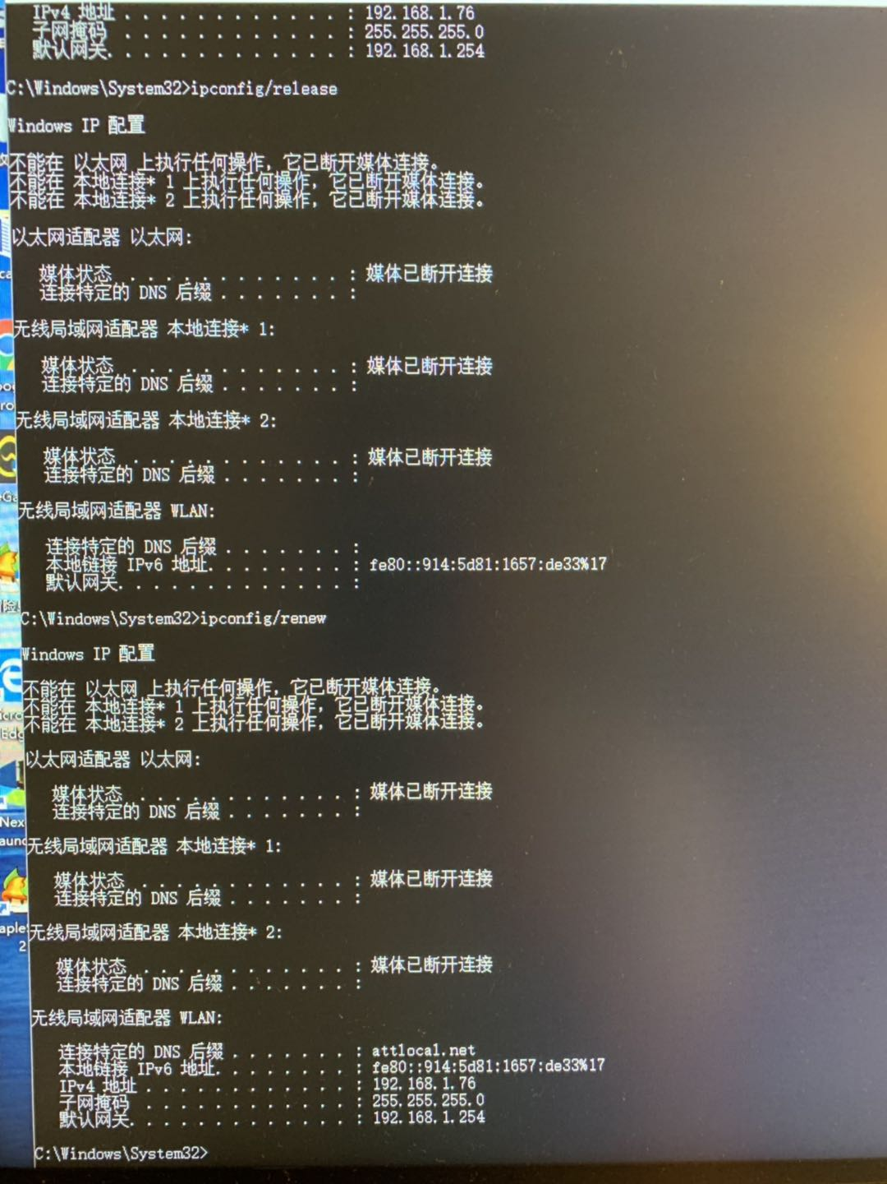0. Screenshot of Command prompt window

1.DHCP uses UDP

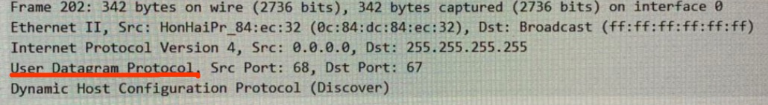

2.DHCP uses client-server architecture

3. port number indicated in Question 1: src port:68 dst port:67

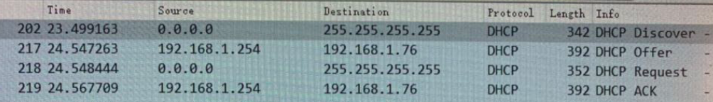

Server Client

<-----Discover

Offer------>

<-------Request

Acknowledge----->

4.

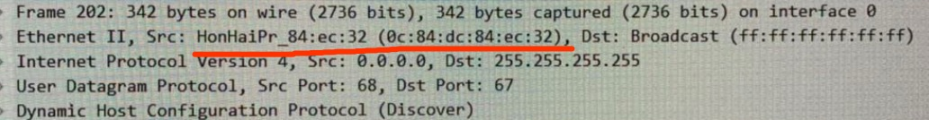

5.

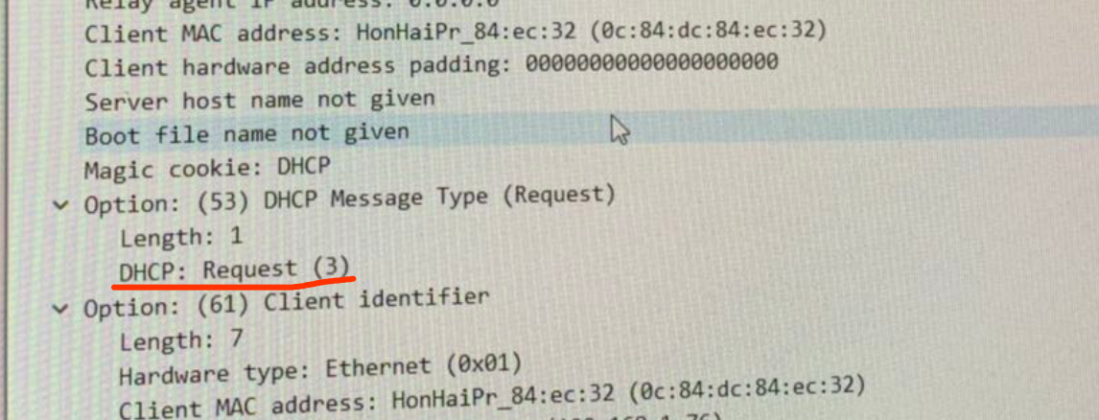

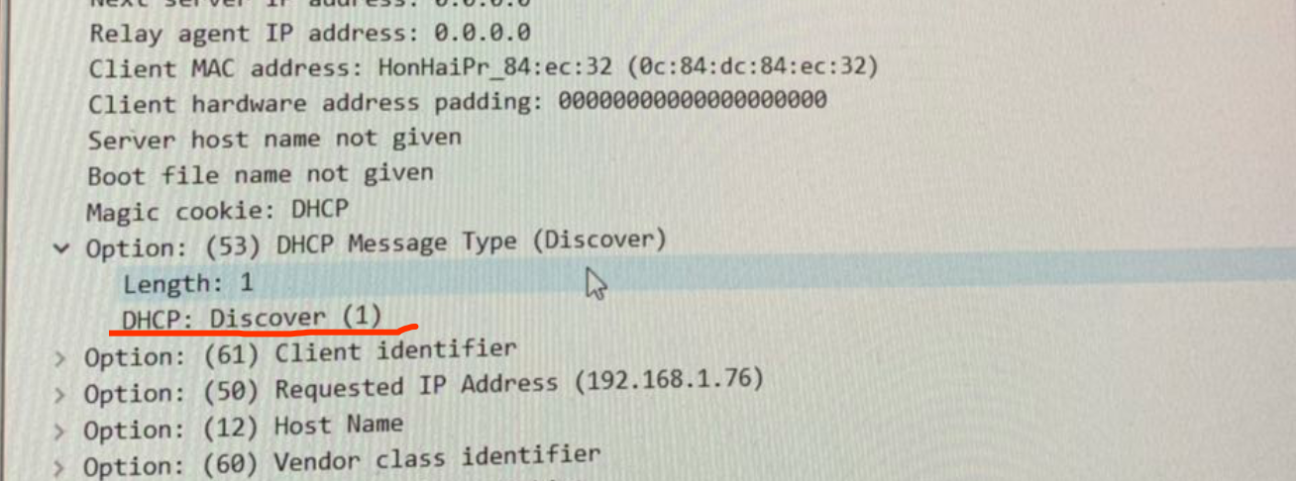

6. first HDCP in red, second HDCP in green. Transaction-ID is for the client to identify different DHCP.

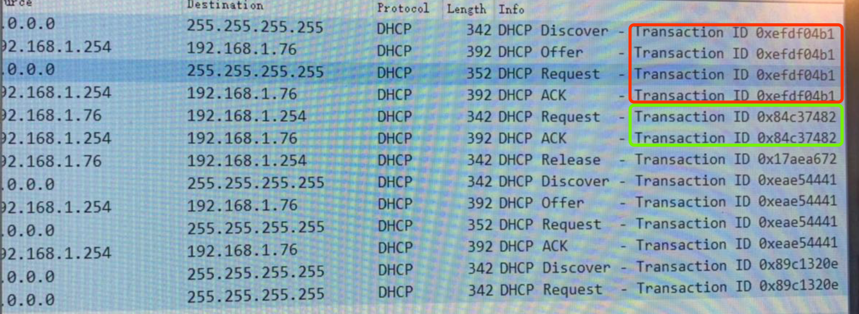

7. Host is using 0.0.0.0 as source IP, 255.255.255.255 as destination IP. Server uses it real IP 192.168.1.254 as source IP and the offered IP as destination IP

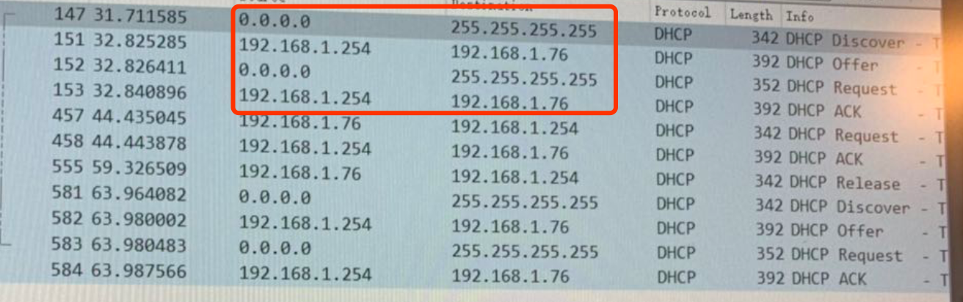

8. Indicated above, 192.168.1.254

9.The Server offered 192.168.1.76 to my machine, lease time 1 day. The IP contained in DHCP message type(offer)

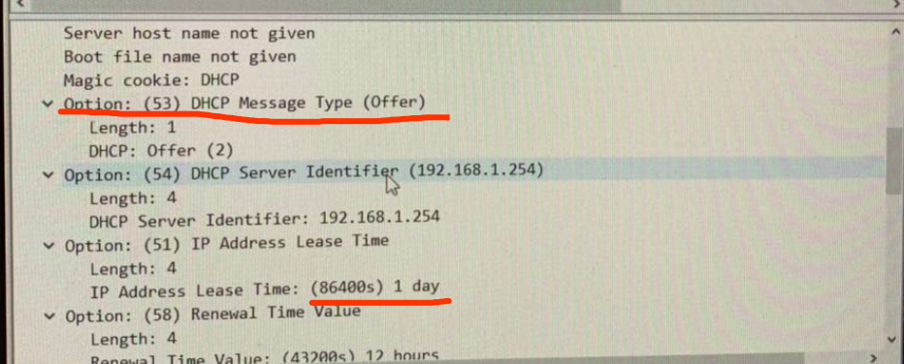

10. It provides renewal time value, rebinding time value, subnet mask, router, domain name server etc.

11. No relay router because its IP is 0.0.0.0

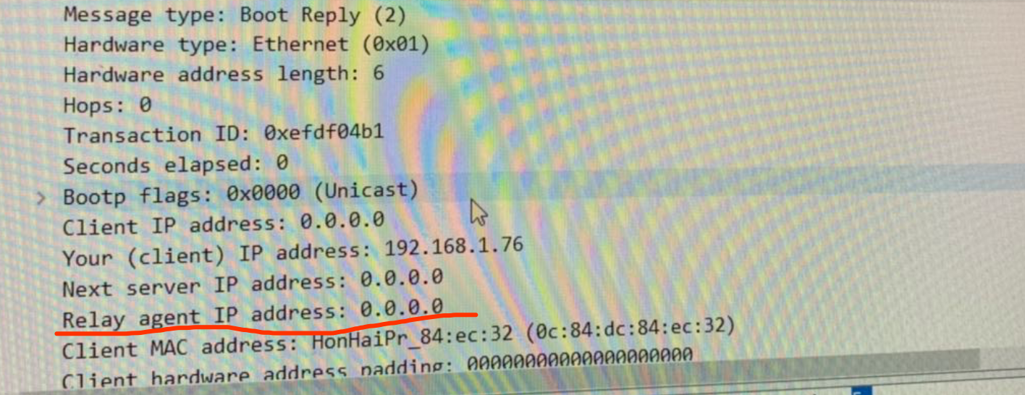

12.The router indicate the router that client should use, same as the subnet mask

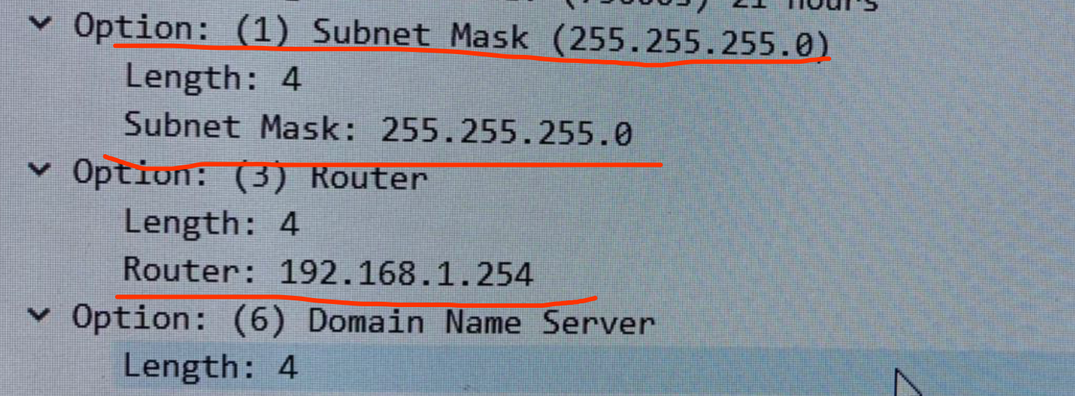

13. It accepted

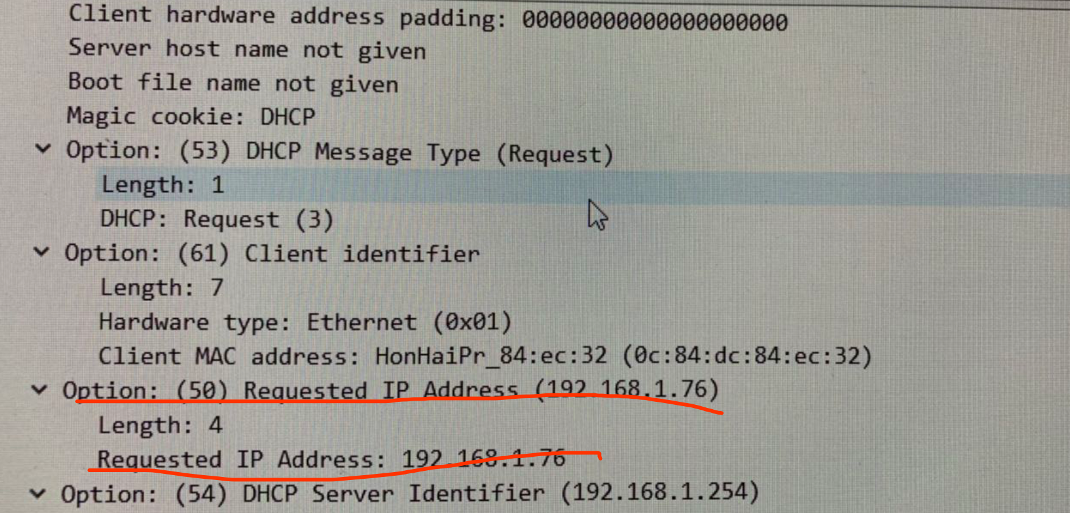

14.Client sent a release message to server to release its current IP from Server, the Server does not send ACK to it. If the release, server will wait to the lease time to expire, to allocate this IP to other.

15.ARP is used to map MAC address with new IP. There are 2 in DHCP period.

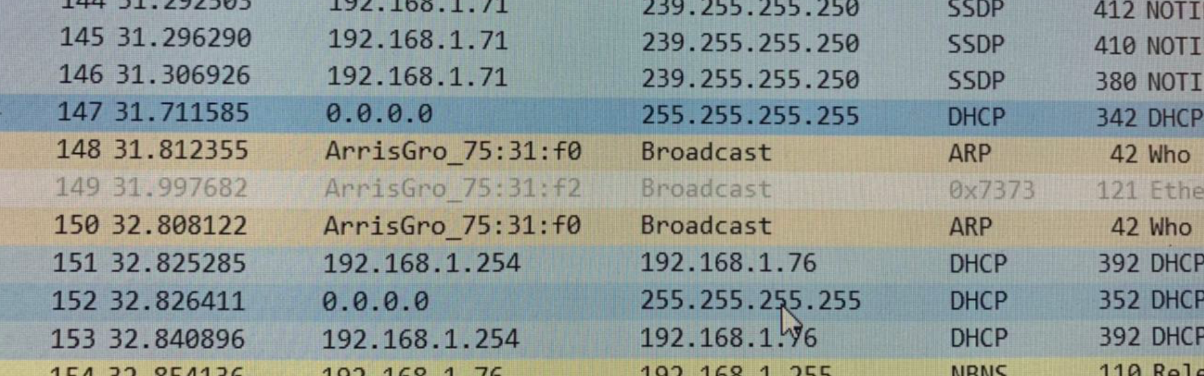

16.Internet Address is the IP address; physical address is the MAC address; Type is dynamic or static.

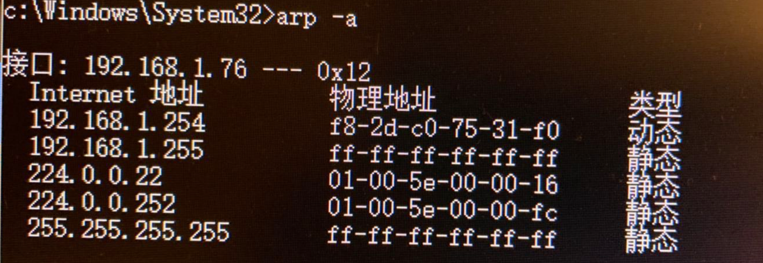

17.src: 8c:85:90:33:be:23 dst:ff:ff:ff:ff:ff:ff

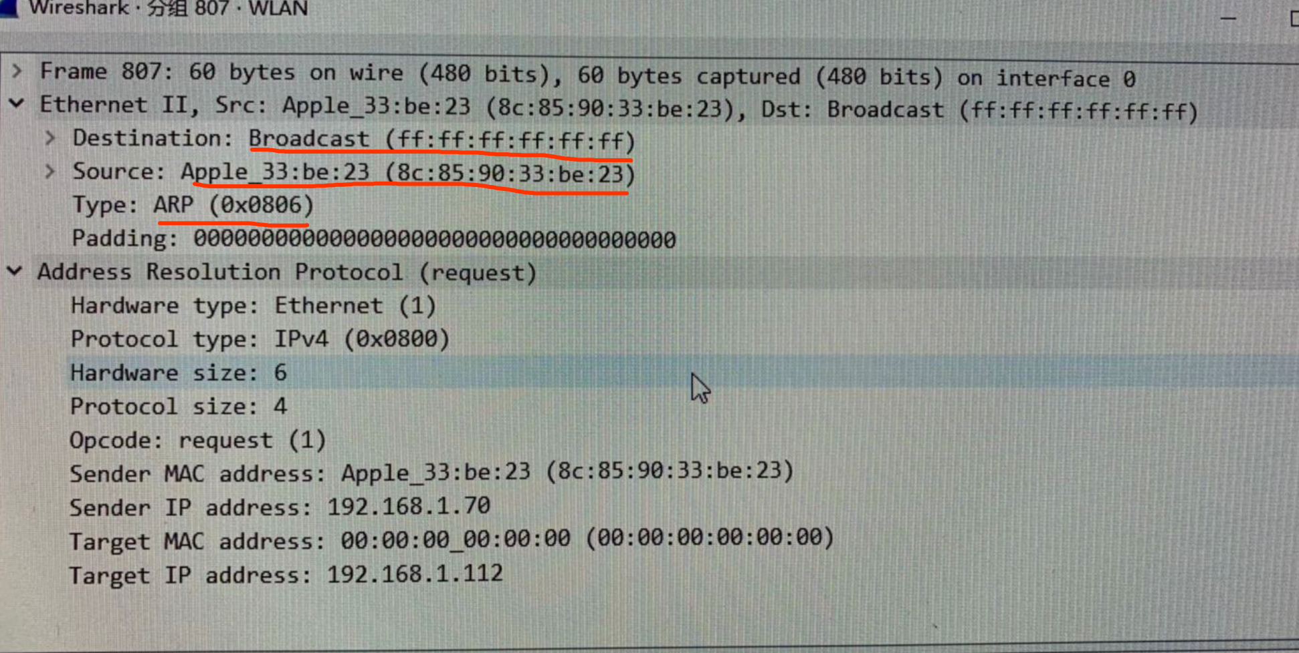

18.0x0806 as shown above, 1 for request

19. (1) 20 bytes (2) 1 is for request (3) Yes (4)From Target MAC address

20. (1) 20 bytes (2) 2 is for reply (3) in Sender MAC

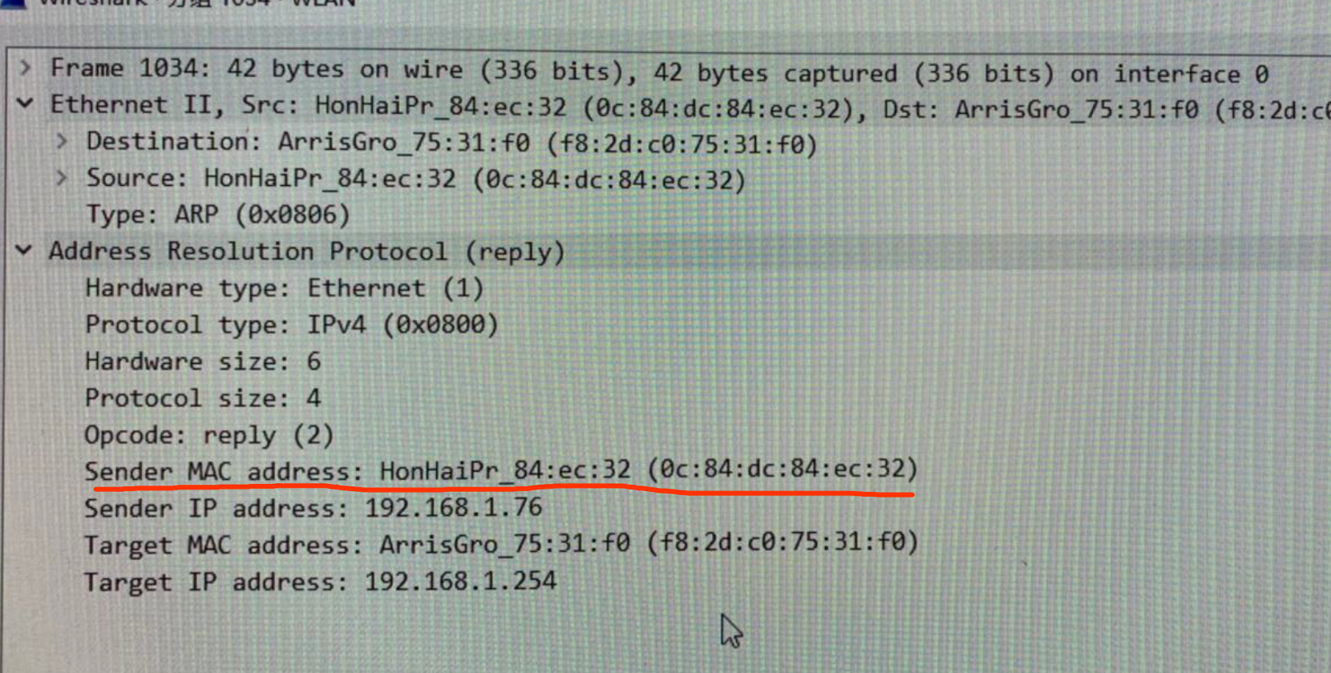

21.src: 0C:84:DC:84:EC:32 dst:f8:2d:c0:75:31:f0 shown as above

22.because ARP request is broadcast, but reply is directly send to server.